## Project Description:

Final Project: Vanguard Prep Academy website

I have been taking these courses at BYU Idaho specifically so I could design and implement a website for a non-profit organization, which I run, and specifically for the Vanguard Prep Academy, which I hope to start at some point

## Purpose of Site:

This is a full-time preparatory academy that develops young leaders who want to focus on learning in an environment where prayer and worship are not only encouraged but scheduled into the learning day.

Recruit staff, volunteers, and parents who will enroll their children in our school.

Allow students to get excited about our program, and voluntarily commit to our more rigorous standards.

Define important terms within our program (Military-Style, Age-Appropriate, STEM-centric, College-Preparatory, PACES, ACE, CAP, Scouts, Cadet, Junior-Cadet, Cubicle, )

Sign up for information, enrollment, or to ask questions.

## Target Market:

Service-minded adults and students with Christian values who believe in youth development, have a strong love for the Savior, and integrate his teachings into daily life. They are committed to standing up for what is right, fostering lifelong learning, and striving for exceptional achievement.

## User Personas:

Volunteers:

Potential Staff:

Parent:

Student- Potential Cadet:

General Public:

Benefactor:

## Scenarios:

A parent wants to know if their student, who has been suspended from another school, can come to the Military Style School to be disciplined.

A high school student is looking for a challenging environment that is rich in experiential learning and wants to learn to become a better leader.

A junior high student wants to make up some subjects that they consider themselves harder to learn. They would like to get to grade level work.

An adult would like to join as a volunteer for the classroom, or activity of the partner organizations.

A student would like to earn certificates and credits that could be applied towards careers of which are self-disciplined in nature such as pilot, EMS, Medical, Search and Rescue, emergency preparedness, etc.

## SEO Plan:

Keywords- (in site descriptions, content)

Verify Googles Business Profile

Put link on information page for students, parents, volunteers to link to their sites

Embed Google Analytics in all site pages.

Words: military, military-style, Christian, god, values, character, motivation, strength,

## SITE PAGES:

# Header:

Logo, “Who Endures Conquers”- Latin: “Vincit Qui Patitur”, Vanguard Prep Academy, Social Media buttons, hamburger menu for small screens. Well designed Header and Navigation menus.

# Aside:

Banner changes with every page that has positive statement, image, or video clip.

Stats on private education benefits

## HOME/INDEX:

History of Vanguard

What we believe

Why we believe in a Year-around, Christ-Centered, Military-Style, STEM-Centric program

Benefits

Hero Image of Cadets

Get More Information button which opens dialog box to receive:

LastName, FirstName; parent or cadet; street address, city,

state; phone-number; (Json File)

-Form action page

Donate Button:

Tell about donating in Idaho and potential tax breaks.

501C3 number and information

Contact us information

* ZenQuotes API: Provides motivational quotes and life wisdom??

## Discover a Life Education Experience

STEM-CENTRIC

Curriculum

Try-Its:

Job-Shadowing and Field Trips;

Certifications

Badges and Ribbons for pursuing qualifications to support community emergency operations.

## Join Enroll and Serve

Vanguard Prep Composite Squadron – Civil Air Patrol- 12 – 112YO

Vanguard Prep Scouts of America – Junior Cadets – grade 3-6

Volunteer Positions

Staff Openings

Application Process

Consent to do Background Checks

# Footer:

Corporate Address

Copyright date

Updated date

Site map

Mapquest or google maps api

## Information to include:

## Cadet Life:

Ace School of Tomorrow curriculum

Partner organizations

Links to Civil Air Patrol, and Scouts of America

A Week in the life of a Vanguard Cadet

Small rotating or montage of cadet image

## Vanguard Community Emergency Response Teams

FEMA certifications

CERT Team

Adult

Youth

## Staff, Volunteers, Cadets:

Board of Directors

Advisory Board

Volunteers and Parent/Guardian chaperones

Cadet Leadership

Students

Adult Leadership

Volunteers

Parent-Grandparent-Guardian Escorts

## Our Christian Beliefs and Commitment:

Uniforms- symbolic of armor of God

Christian Path

Time for Prayer

Strength in character Development

Lying, Cheating, Stealing

Respect for ourselves and others

Civility and Courtesy

Garbage In Garbage Out

## Financial Obligation and policy:

Enrollment Fees and other Costs

Payment Plans

Obligation with enrollment acceptance

## External and Internal Opportunities from our associations

Pilot- CAP, EAA, Summer Trip, USAF

Orientation Flight

First Flight

Encampment

Airman Leadership School

NCO Academy

Cadet Officer School

Region Leadership School at USAFA

COS- Maxwell AFB, AL

Emergency Services Training:

Ground SAR Team

Drone Team

Drone Pilot

Flight-Pilot training

Free Pilot Ground School

Annual Flight Academies

Wings program for private pilot

CAP flight instruction opportunities using CAP C172 and CAP instructor pilots

## Font Family

LATO

Regular 400 at 16px

Everyone has the right to freedom of thought, conscience and religion; this right includes freedom to change h

*Black 900 italic*

Black 900

**Bold 700**

***Bold 700 italic***

*Regular 400 italic*

Regular 400

*Light 300 italic*

Light 300

*Thin 100 italic*

Thin 100

## Color Palette

School colors are maroon, golden yellow, dark blue, light blue,

## Palette

#2c71fb

--lightblue-color: #2c71fb

    /*medium blue bright*/

#040fe3

    --medblue-color: #040fe3

    /*med blue */

#2A2547

    --darkblue-color: #2A2547

    /* Darkblue */

#96a3d9

    --lightblue-color: #96a3d9

    --darkpeach-color: #D99C79

#D99C79

    /*backgroundColor*/

    --darkmaroon-color: #3b0b04

#3b0b0

    /*darkmaroon*/

#6c020a

  --medmaroon-color: #6c020a;

    --lightmaroon-color: #af3001;

#af3001

    --deepgold-color: #fcbc46;

#fcbc46

    --lightgold-color: #fee773;

#fee773

## ICONS and FAVICONS

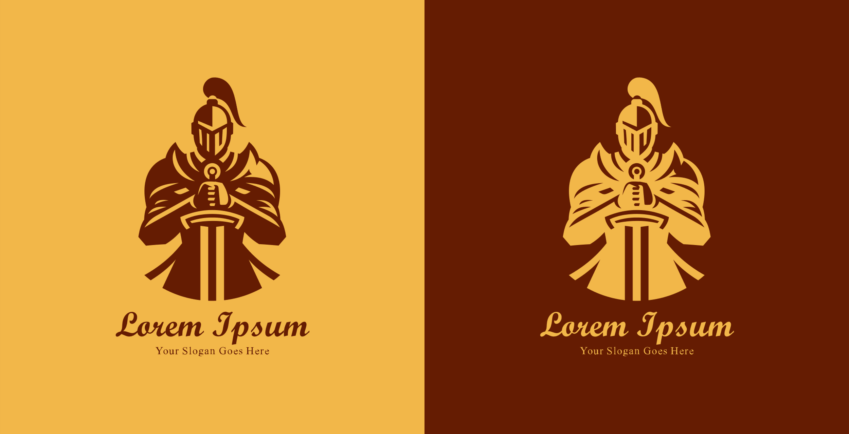

## WireFrames

